Unit 1 The House of My Dreams

A
2. I wish I had a house in the forest.
3. I wish I had a house on a tropical island.
4. I wish I had a house in a city.

B
2. It would also have a living room whose walls have beautiful paintings.
3. It would also have a kitchen whose appliances are modern.
4. It would also have a gym whose equipment is free to use.

C
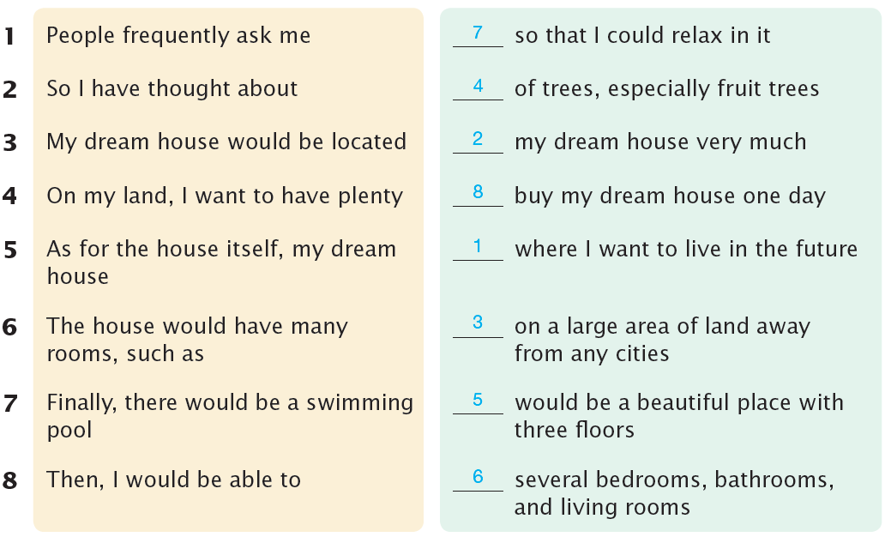
1. People frequently ask me where I want to live in the future.
2. So I have thought about my dream house very much.
3. My dream house would be located on a large area of land away from any cities.
4. On my land, I want to have plenty of trees, especially fruit trees.
5. As for the house itself, my dream house would be a beautiful place with three floors.
6. The house would have many rooms, such as several bedrooms, bathrooms, and living rooms.
7. Finally, there would be a swimming pool so that I could relax in it.
8. Then, I would be able to buy my dream house one day.

Unit 2 Health Habits

A
2. I should have eaten fruits and vegetables more often.
3. I should have gone to bed earlier.
4. I should have washed my face before bed.

B
1. I used to drink plenty of water, but I do not anymore.
2. I used to brush my teeth at least twice a day, but I do not anymore.
3. I used to avoid eating sweets, but I do not anymore.
4. I used to go to the gym every other day, but I do not anymore.

C
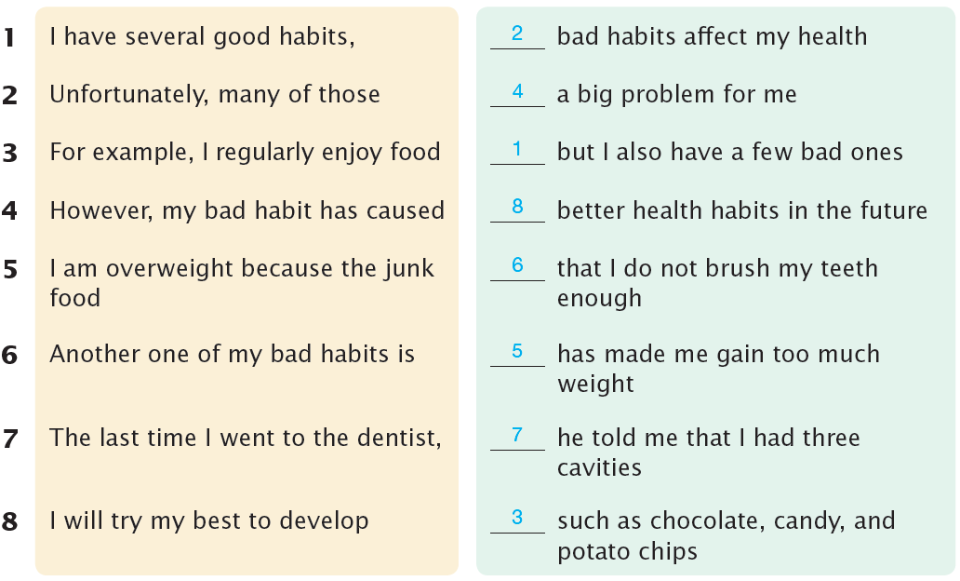

1. I have several good habits, but I also have a few bad ones.
2. Unfortunately, many of those bad habits affect my health.
3. For example, I regularly enjoy food such as chocolate, candy, and potato chips.
4. However, my bad habit has caused a big problem for me.
5. I am overweight because the junk food has made me gain too much weight.
6. Another one of my bad habits is that I do not brush my teeth enough.
7. The last time I went to the dentist, he told me that I had three cavities.
8. I will try my best to develop better health habits in the future.

Unit 3 Popular Festivals

A
2. It is known that India is a very large country.
3. It is known that Boryeong, Korea, is a fun place.
4. It is known that Bunõl is a small town in Spain.

B
2. It is fun to watch canoe races on the icy river.
3. It is exciting to throw tomatoes at each other.
4. It is easy to do many activities during the festival.

C
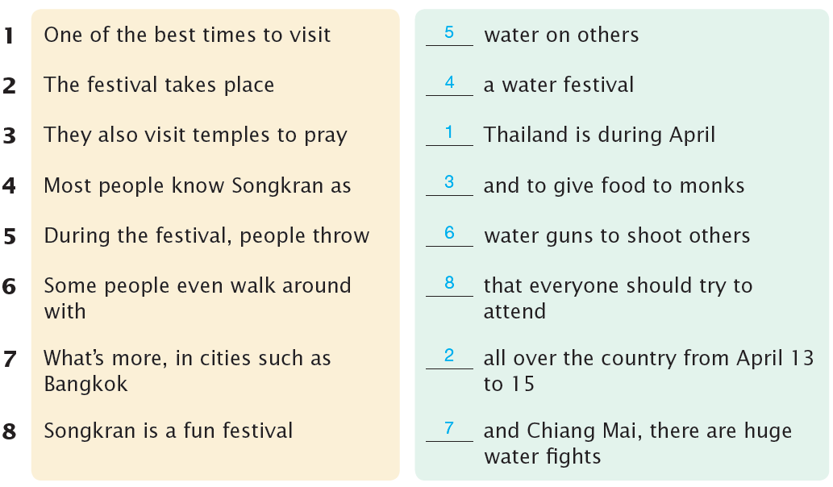

1. One of the best times to visit Thailand is during April.
2. The festival takes place all over the country from April 13 to 15.
3. They also visit temples to pray and to give food to monks.
4. Most people know Songkran as a water festival.
5. During the festival, people throw water on others.
6. Some people even walk around with water guns to shoot others.
7. What’s more, in cities such as Bangkok and Chiang Mai, there are huge water fights.
8. Songkran is a fun festival that everyone should try to attend.

Unit 4 Having a Pet

A
2. Even though I take good care of her, Carrie often bites my arms and legs.
3. Even though Spot seems healthy all the time, he still needs regular checkups.
4. Even though my grandmother lives alone, her dog makes her feel less lonely.

B
2. I am not always the neatest person, but Carrie loves making my bedroom messy.
3. I am not always the most outgoing person, but Teddy helps me meet many new people.
4. I am not always the most responsible person, but Bear helps me learn to care for animals.

C
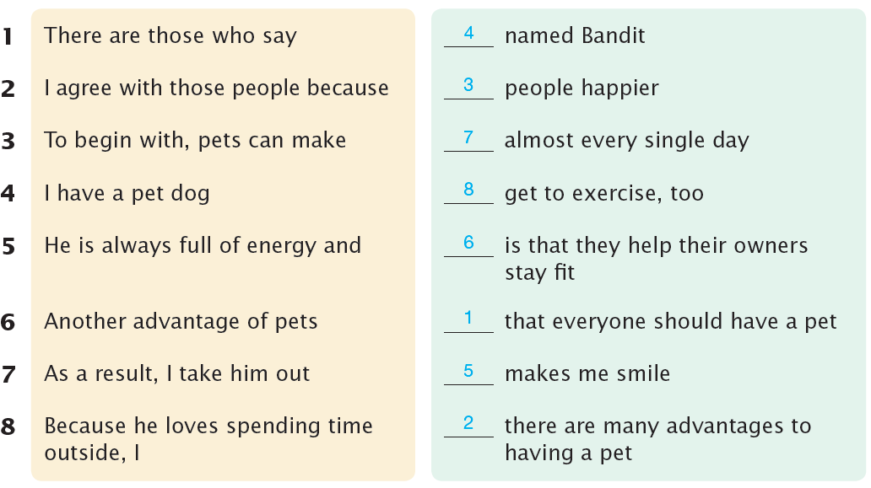

1. There are those who say that everyone should have a pet.
2. I agree with those people because there are many advantages to having a pet.
3. To begin with, pets can make people happier.
4. I have a pet dog named Bandit.
5. He is always full of energy and makes me smile.
6. Another advantage of pets is that they help their owners stay fit.
7. As a result, I take him out almost every single day.
8. Because he loves spending time outside, I get to exercise, too.

Unit 5 Social Networking Services

A
2. SNS is a great way to make new friends.
3. SNS is a great way to share and exchange ideas.
4. SNS is a great way to connect with people all around the world.

B
2. People would rather bully others than be nice.
3. People would rather waste their time than do something useful.
4. People would rather spread personal information rather than keep it secret.

C
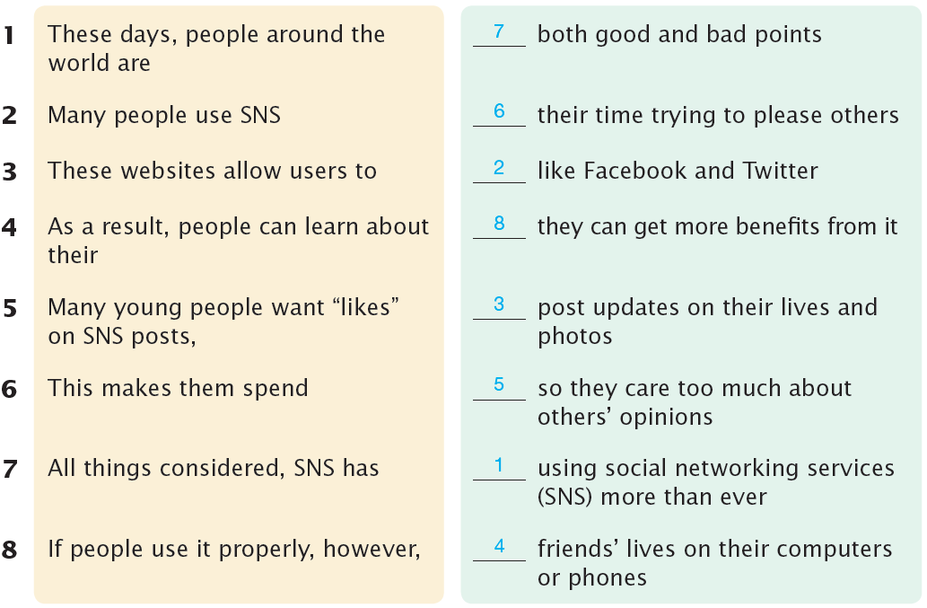

1. These days, people around the world are using social networking services (SNS) more than ever.
2. Many people use SNS like Facebook and Twitter.
3. These websites allow users to post updates on their lives and photos.
4. As a result, people can learn about their friends’ lives on their computers or phones.
5. Many young people want “likes” on SNS posts, so they care too much about others’ opinions.
6. This makes them spend their time trying to please others.
7. All things considered, SNS has both good and bad points.
8. If people use it properly, however, they can get more benefits from it.

Unit 6 Traveling

A
2. I can enjoy my life much better by spending money.
For example, I may want to go to a concert with my friend.
3. I can prepare for problems in the future by saving money.
For example, I may have to quit my job.
4. I can use many different transportation systems in the city.
For example, I may go to a place far away from my house.

B
2. Since traveling brings me great joy, I spend money on it.
3. Since the pace of life is slower in the country, it is more peaceful.
4. Since there are more job opportunities in a city, it is easier to find a job.

C
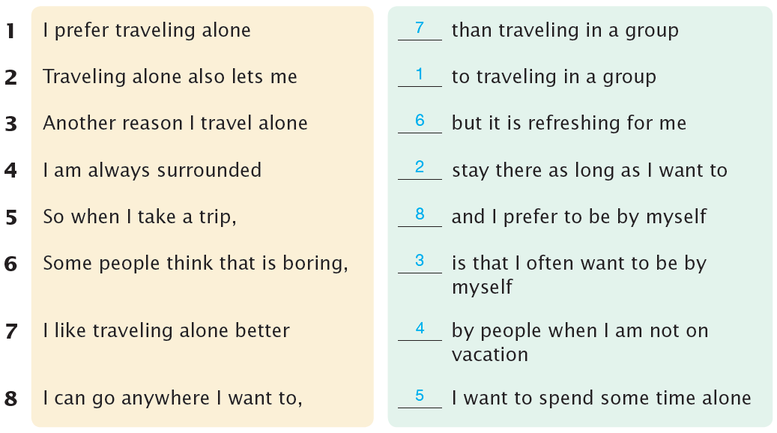

1. I prefer traveling alone to traveling in a group.
2. Traveling alone also lets me stay there as long as I want to.
3. Another reason I travel alone is that I often want to be by myself.
4. I am always surrounded by people when I am not on vacation.
5. So when I take a trip, I want to spend some time alone.
6. Some people think that is boring, but it is refreshing for me.
7. I like traveling alone better than traveling in a group.
8. I can go anywhere I want to, and I prefer to be by myself.

Unit 7 Two Sports

A
2. Like volleyball, a tennis court has a net in the middle of it.
3. Like badminton, ping-pong can be played as singles or doubles.
4. Like polo, ice hockey players move around a lot during a game.

B
2. Ping-pong paddles are not as long as badminton rackets.
3. Ice hockey is not as old as polo.
4. A tennis ball is not as big as a volleyball.

C
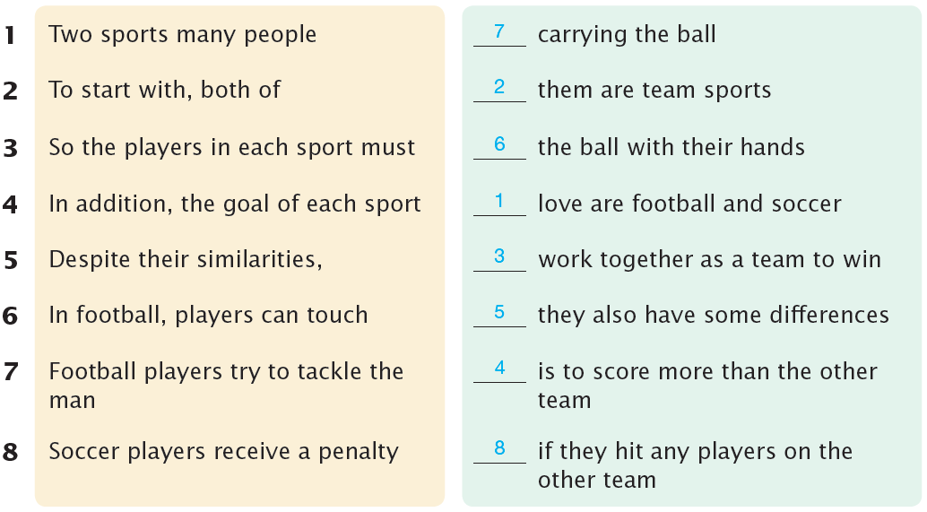

1. Two sports many people love are football and soccer.
2. To start with, both of them are team sports.
3. So the players in each sport must work together as a team to win.
4. In addition, the goal of each sport is to score more than the other team.
5. Despite their similarities, they also have some differences.
6. In football, players can touch the ball with their hands.
7. Football players try to tackle the man carrying the ball.
8. Soccer players receive a penalty if they hit any players on the other team.

Unit 8 Advanced Technology

A
2. In fact, no machines can produce things more cheaply than 3D printers.
3. In fact, no vehicles can fly around the Earth faster than airplanes.
4. In fact, no people can drive more smartly than self-driving cars.

B
2. Whether people want to play games or listen to music, they can use their computers.
3. Whether the design is simple or complex, their 3D printers can make it.
4. Whether it rains or snows, the weather conditions are not a problem to self-driving cars.

C
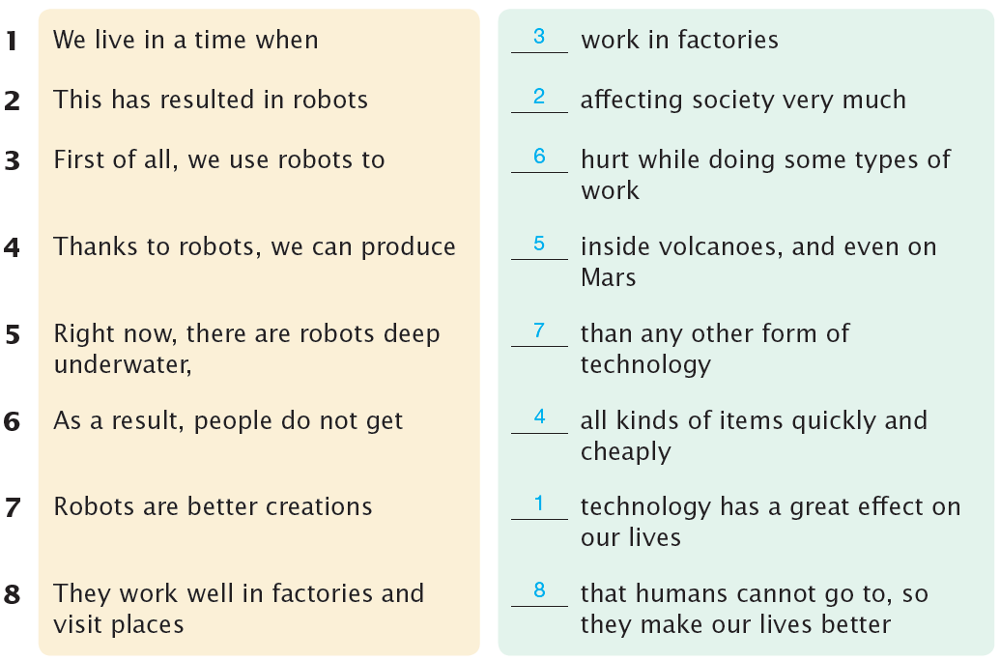

1. We live in a time when technology has a great effect on our lives.
2. This has resulted in robots affecting society very much.
3. First of all, we use robots to work in factories.
4. Thanks to robots, we can produce all kinds of items quickly and cheaply.
5. Right now, there are robots deep underwater, inside volcanoes, and even on Mars.
6. As a result, people do not get hurt while doing some types of work.
7. Robots are better creations than any other form of technology.
8 They work well in factories and visit places that humans cannot go to, so they make our lives better.

